Steps to create a Django Project

==========================

1) Open Command Prompt and Move to the Project Location .

2) To Create Project Type Command as

django-admin startproject <Project_name>

3) Move into Created Project Folder in command Prompt.

cd <Project_name>

4) Create a app in Project

Note : One Project can have any number of apps

django-admin startapp <app_name>

5) To Start the server

Note : Be into Project folder

python manage.py runserver

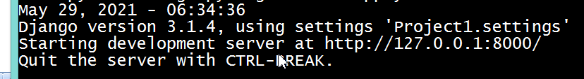

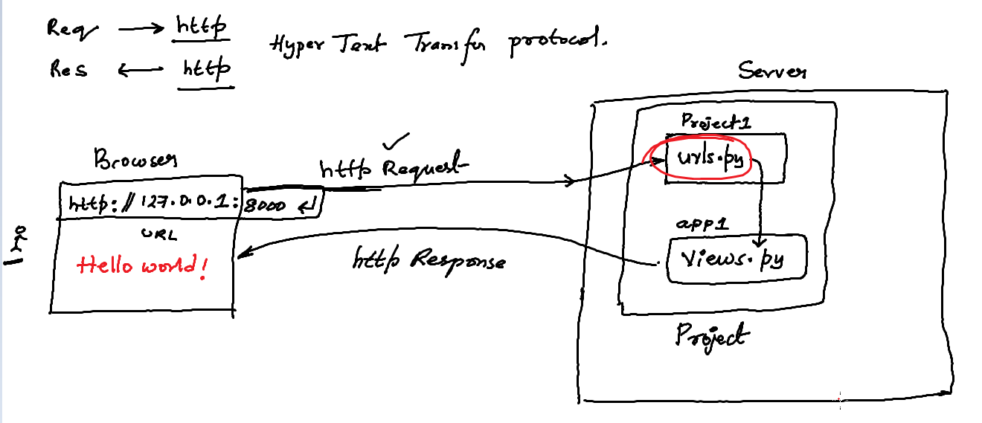

Hello World Program